

**e-Yantra Robotics Competition Plus**

**<eYRC#PS2#3959>**

|  |  |
| --- | --- |
| **Team leader name** | **NIKHIL MEHRA** |
| **College** | **DRONACHARYA COLLEGE OF ENGINEERING** |
| **Email** | **mehranikhil204@gmail.com** |
| **Theme assigned** | **Puzzle Solver 2(Mechanical Arm)** |
| **Date** | **25/01/2016** |

**Scope (5)**

**State the scope of the theme assigned to you.**

Ans The scope of the assigned theme “Puzzle Solver Robot (Mechanical Arm)” is vast in nature as it can be applied in organized stacking of goods and raw materials in the inventories, warehouses, docks, manufacturing units etc. This theme can be further implemented to a variety of projects such as Butler Robots (sorting the utensils and placing them orderly), in military to fetch resources to the specific base camps after identifying those camps and many more. Furthermore, this theme can be a major advance in AI (artificial intelligence) projects because image processing can be utilized to solve difficult problems.

**Building Modules (5)**

**Identify the major components required for designing the robotic system for the solution of the theme assigned to you.**

Ans 1. Mechanical System

1. Spur Gears: For movement of the grippers.
2. Grippers: For picking and holding the blocks.
3. Linkages: For making different parts of the structure of the mechanical arm.
4. Lead Screw: For converting rotating motion of the motors into linear motion (up and down) of the arm.
5. Nuts and Bolts : For joining different linkages
6. Magnets: For connecting and disconnecting the motor shaft and grippers.

2. Electrical Systems

a. DC Servo-Motor (4.8V - 6V), DC Motors: For rotating motion of the arm

b. Connecting Wires: For making different electrical connections.

**Environment sensing (5)**

**Explain the functioning of environment sensing technique used by Firebird V robot in your theme.**

Ans 1. White Line Sensors: It is a 10A avoiding sensor in multirobot or obstacle environment used to follow the black line in the matrices D1 and D2.

2. IR Sharp Sensor: To detect the blocks in the matrix and for the accurate distance measurement. It is same for different colored objects as measured distance is function of the angle of reflection and not on the reflected light intensity.

3. Position Encoders: These are mounted on the both the motor’s axles to give a position feedback to the microcontroller and to measure the distance travelled by the robot.

**Power Management (5)**

**Explain the power management system required for a robot in general and for Firebird V robot in particular.**

Ans 1. Our system is powered by a rechargeable, 2100mAh NiMH, 9.6 V with two-hour battery life when two geared-motors are operational 75% all the time:

A) In our system, two DC geared-motors are used to drive the wheels in the robot.

B) Three servo-motors, each of 4.8-6 V, are employed in the mechanical arm positioned at the front of the robot. Each servo-motor consumes 2000 mA at no load.

C) Three white line sensors are used with a range of 2 to 3.3V.

D) One 2 x 16 Characters LCD is used with a consumption of 20mA.

E) A Buzzer is also used.

**Testing your knowledge (related to rulebook) (20)**

**Describe the process of completing the Single Number in D2, by adding different Numbers from D1.**

Ans 1. Robot will start moving forward from the start line with castor wheel positioned on the line.

2. Using Grid solving algorithm robot will move to the required node for picking of the block.

3. After reaching at the node mechanical arm will pick up the block.

4. All blocks required to make the sum will be picked up by mechanical arm. But mechanical arm will only pick maximum of three blocks.

5. Then, robot will traverse to matrix 2 to the required node where it will release all the blocks.

6. Robot will give a buzzer for 1000ms after completing each sum and will give a continuous buzzer after completing the whole task(in this case all the given sums)

**Design Analysis (30)**

**Q1. Teams have to make a mechanism for picking and placing the Blocks from D1 to D2.**

1. **Choose an option to position the mechanism on the robot and why?**
2. **Front 2. Back 3. Right/Left**

Ans The mechanism for picking and placing the blocks from D1 to D2 is placed at the front of the Robot because the robot will first traverse the path using black line and will reach the node (black junction). From the junction the robot will turn 45◦ and align the gripper with the block be picked. Then the block is picked from the front of the robot and the gripper is raised high up such that when the robot moves it does not collide with other blocks. Also it is placed at the front due to the fact that pushing is easier than pulling specially in the case of our robot. Therefore the mechanism for picking and placing the block is positioned at the front of firebird V robot.

1. **Explain the design of the mechanism and how it is mounted on the robot.**

Ans Materials of various components:

1. Structural linkages : Wooden and plastic linkages, usually found in a toy set
2. Gears : Plastic
3. Grippers : Plastic or wooden
4. Lead Screw : Stainless steel or cast Iron
5. Round Disc : Plastic

Mechanical arm consists of three motors. One motor rotates the lead screw, which in turn converts the rotatory motion of the motor into the linear motion (up and down) of the round disc. Vertical motion of the round disc is needed in order to avoid collision with the other blocks. Second motor rotates the round disc. Round disc consists of three grippers with 120 degrees of angle between each gripper. Third motor helps the gripper to pick and release the block. Round disc rotates and changes the position of grippers such that each time a new gripper picks up the block. Maximum of three blocks can be picked up by the rotating disc. Magnets helps in connecting and disconnecting the shaft of the motor and the grippers. Rubber bands are used to restrict the movement of grippers when they are not connected by the motor shaft.

The below SolidWorks figure shows a rough sketch of the mechanical arm. The position of two motors are shown in the figures. Magnets and rubber bands are also omitted from the figures.

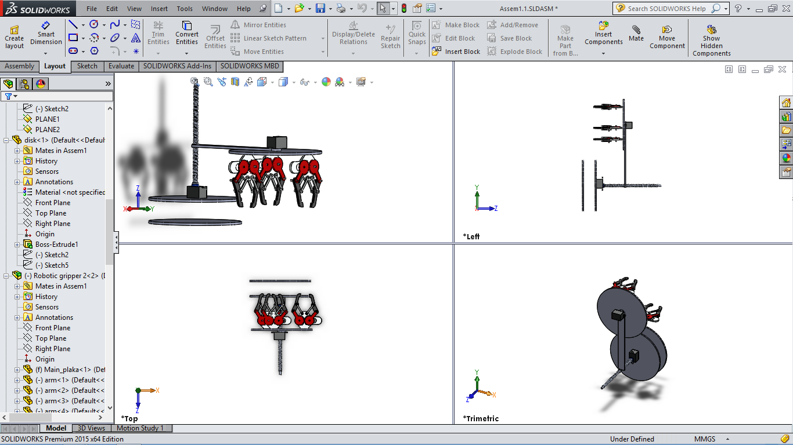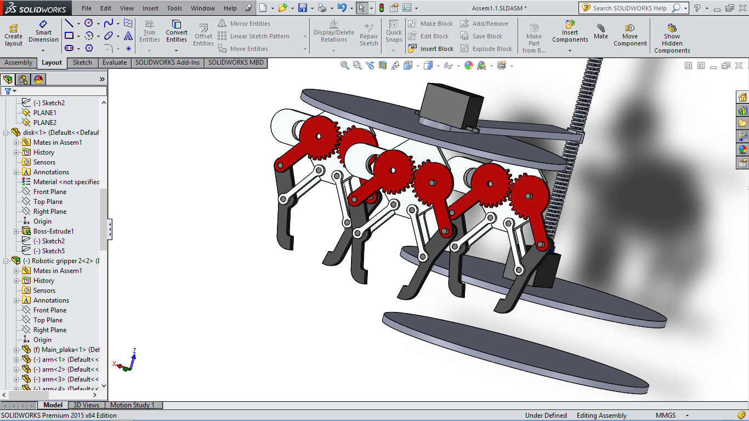

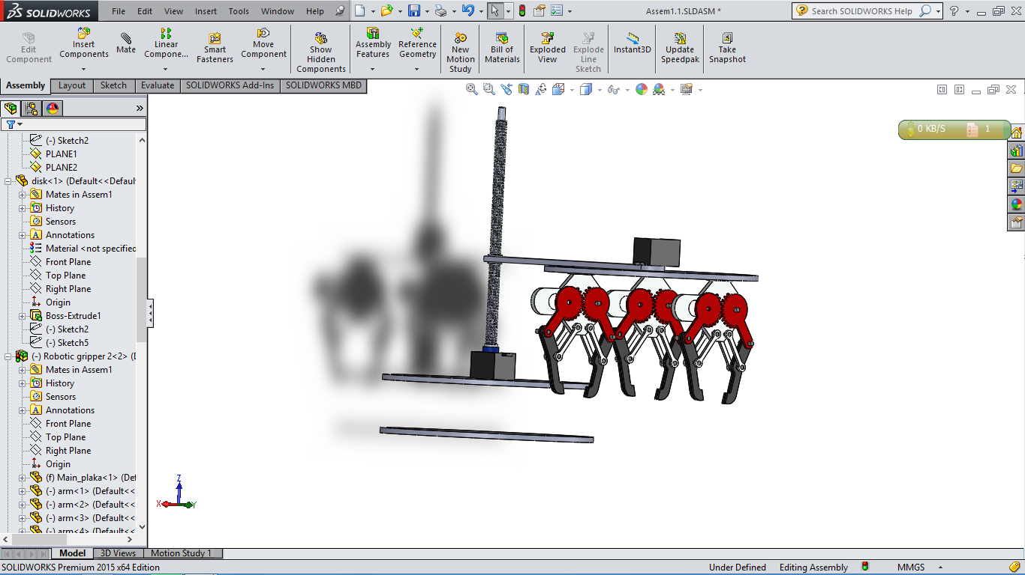

1. **To design the mechanism for picking and placing the Blocks, what challenge/s do you expect to face and how will you overcome them?**
2. Challenge: To stabilize the robot by reducing toppling moment after connecting the mechanical arm.

Solution: The mechanical arm has such a stabilized paradigm that it gives overall stability to the robot.

1. Challenge: There are only three servo-motor ports available in firebird V.

Solution: Therefore, the mechanical arm is designed such that only three servo-motors are used.

1. Challenge: To avoid collision with blocks during the motion of the robot.

Solution: Power screw mechanism is used for converting rotation of the motor into linear (up and down) motion of the mechanical arm.

1. Challenge: To minimize the time consumption, more than one block (2 to 3 blocks) are to be picked.

Solution: Designed the mechanical arm in such a way that it is capable of picking more than block (3 blocks).

1. Challenge: To hold a block and pick another block simultaneously.

Solution: The design of the mechanical arm consists of a rotating disc which solves the above challenge.

1. Challenge: How to use one servo-motor for three different grippers.

Solution: This challenge is solved using magnets which joins each gripper with the motor shaft.

1. Challenge: To make the mechanical arm light weight.

Solution: Plastic components are mainly used in making the structure of the design.

**Algorithm Analysis**

**(25)**

**Q-1 Draw a flowchart illustrating the major functions that are used.**

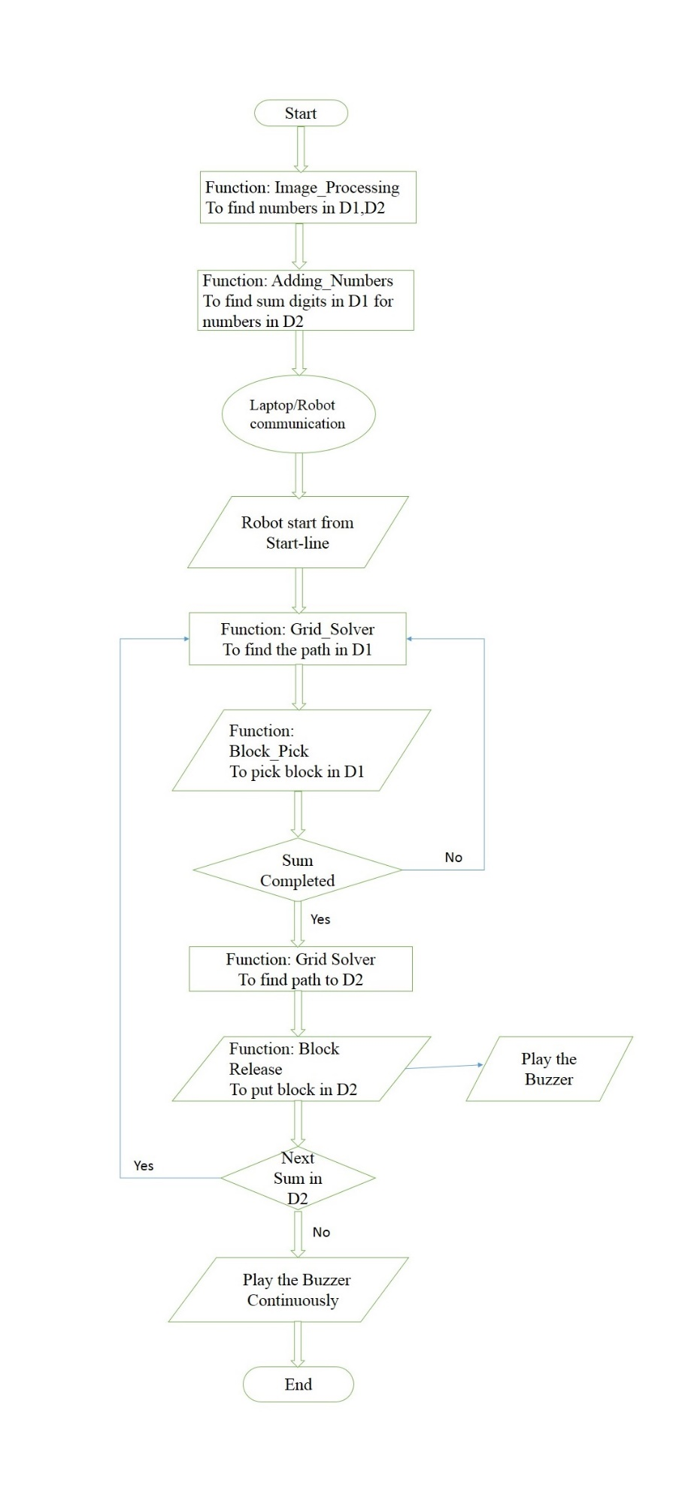

**Q-2 Draw a flowchart illustrating main function of your code.**

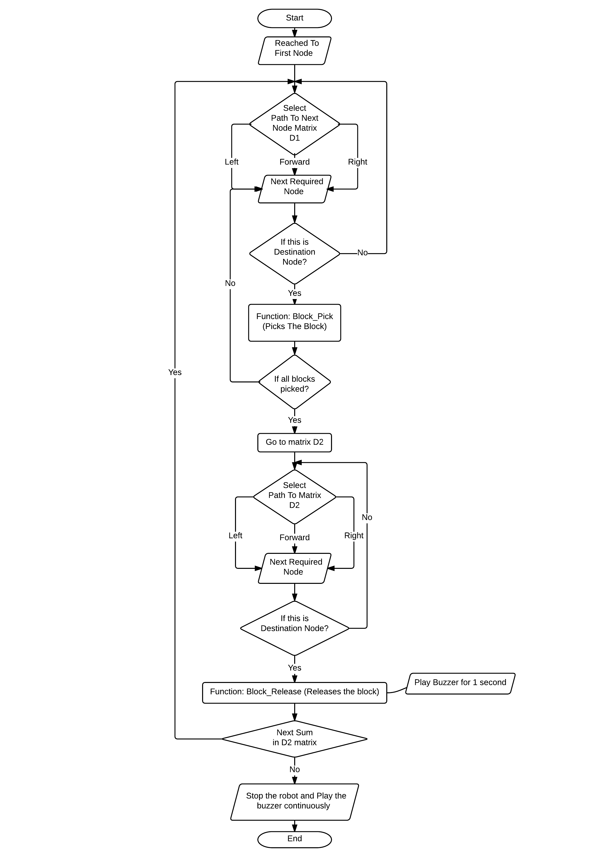

**Challenges**

**(5)**

**What are the major challenges that you can anticipate in addressing this theme?**

Ans:

1. How to get the task completed within the minimum time consumed.
2. How to pick up a block without bumping into others.
3. How to find the optimum path using grid solver.
4. To pick or release a block from the corner of the square.
5. Interfacing of the mechanical arm with Firebird V.